Chapter 1.2.2 Google Cloud Libraries, Cloud SDK and Firebase SDK

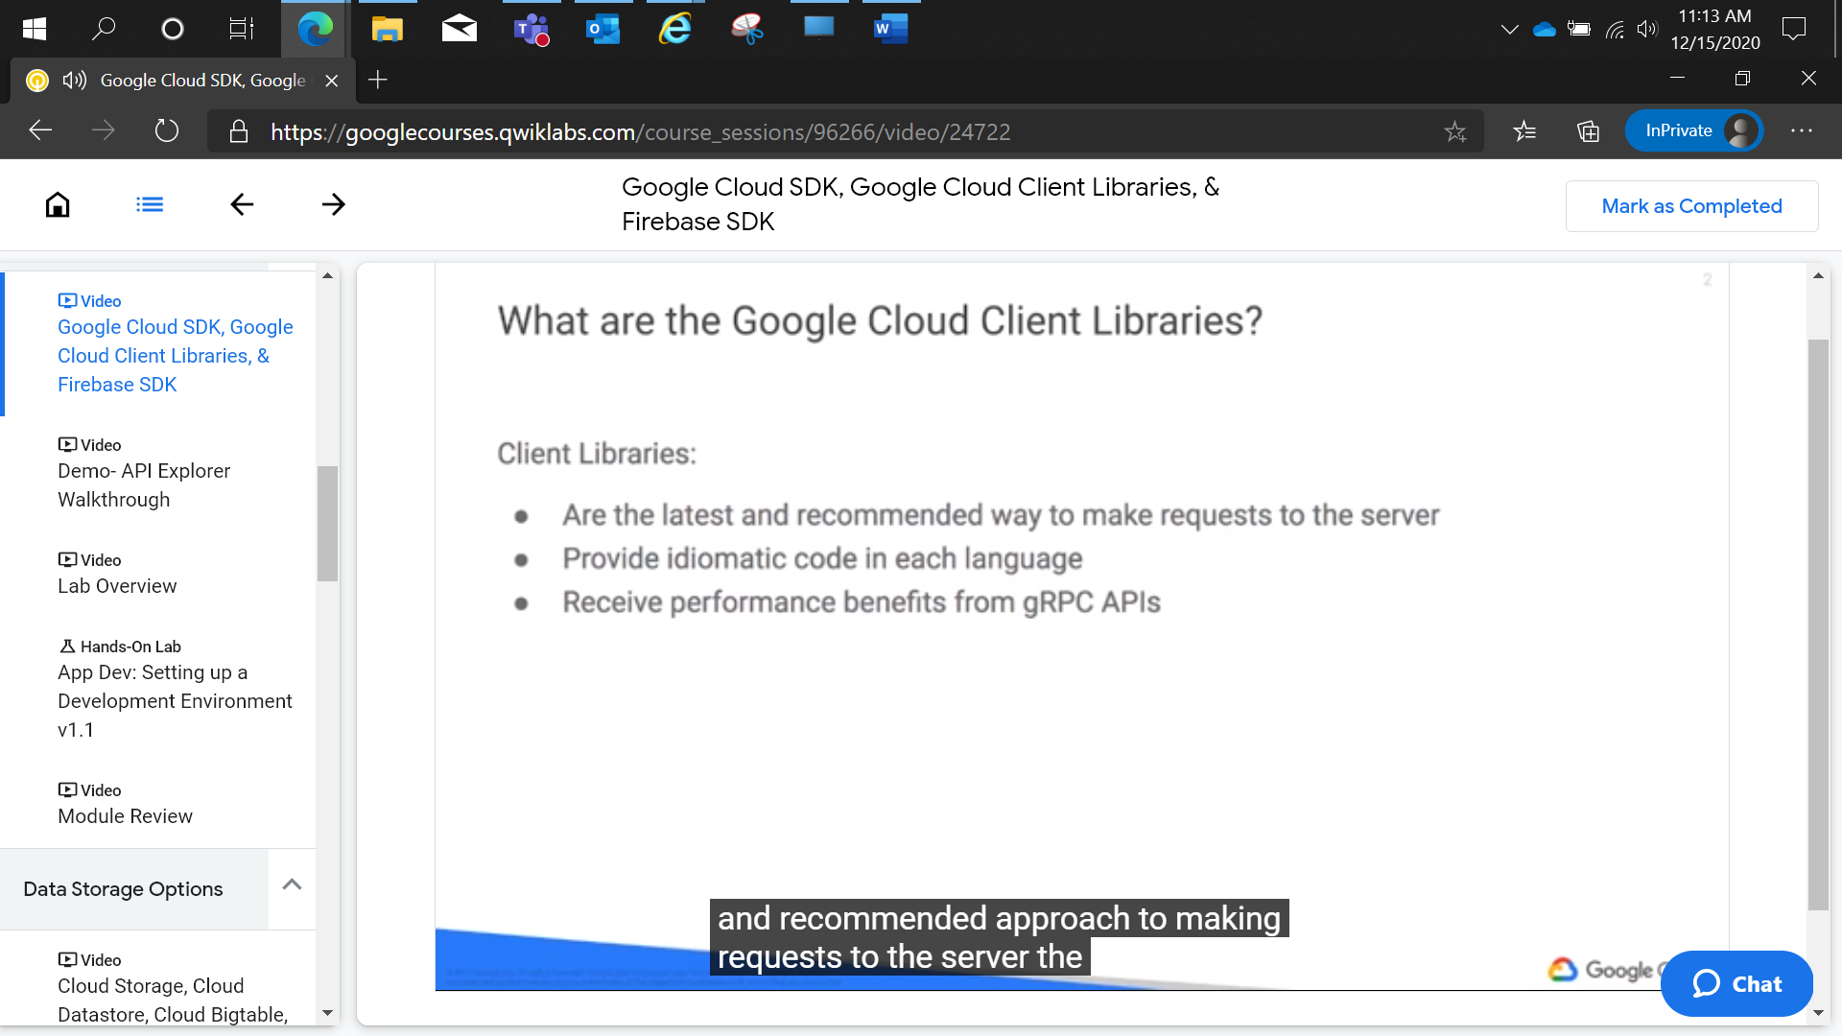

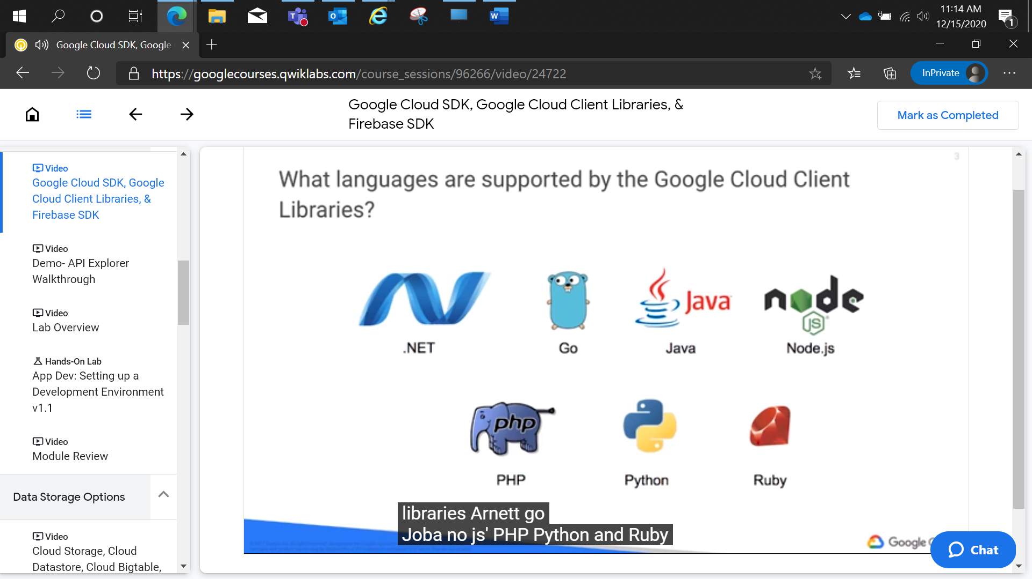

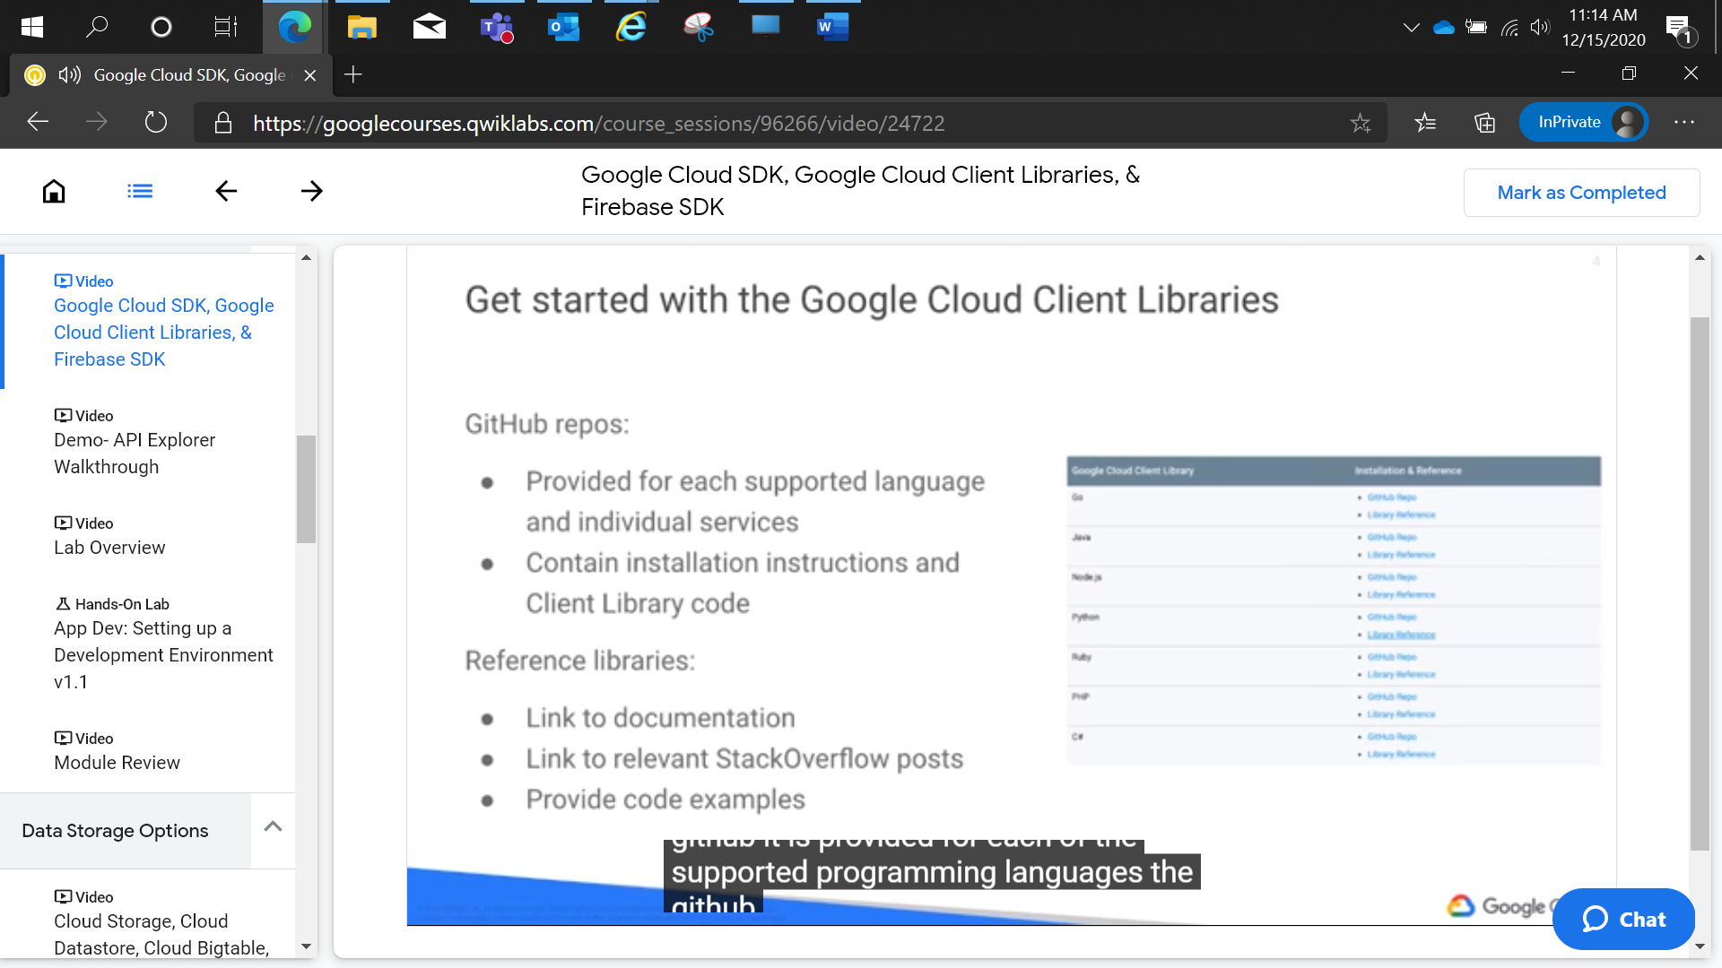

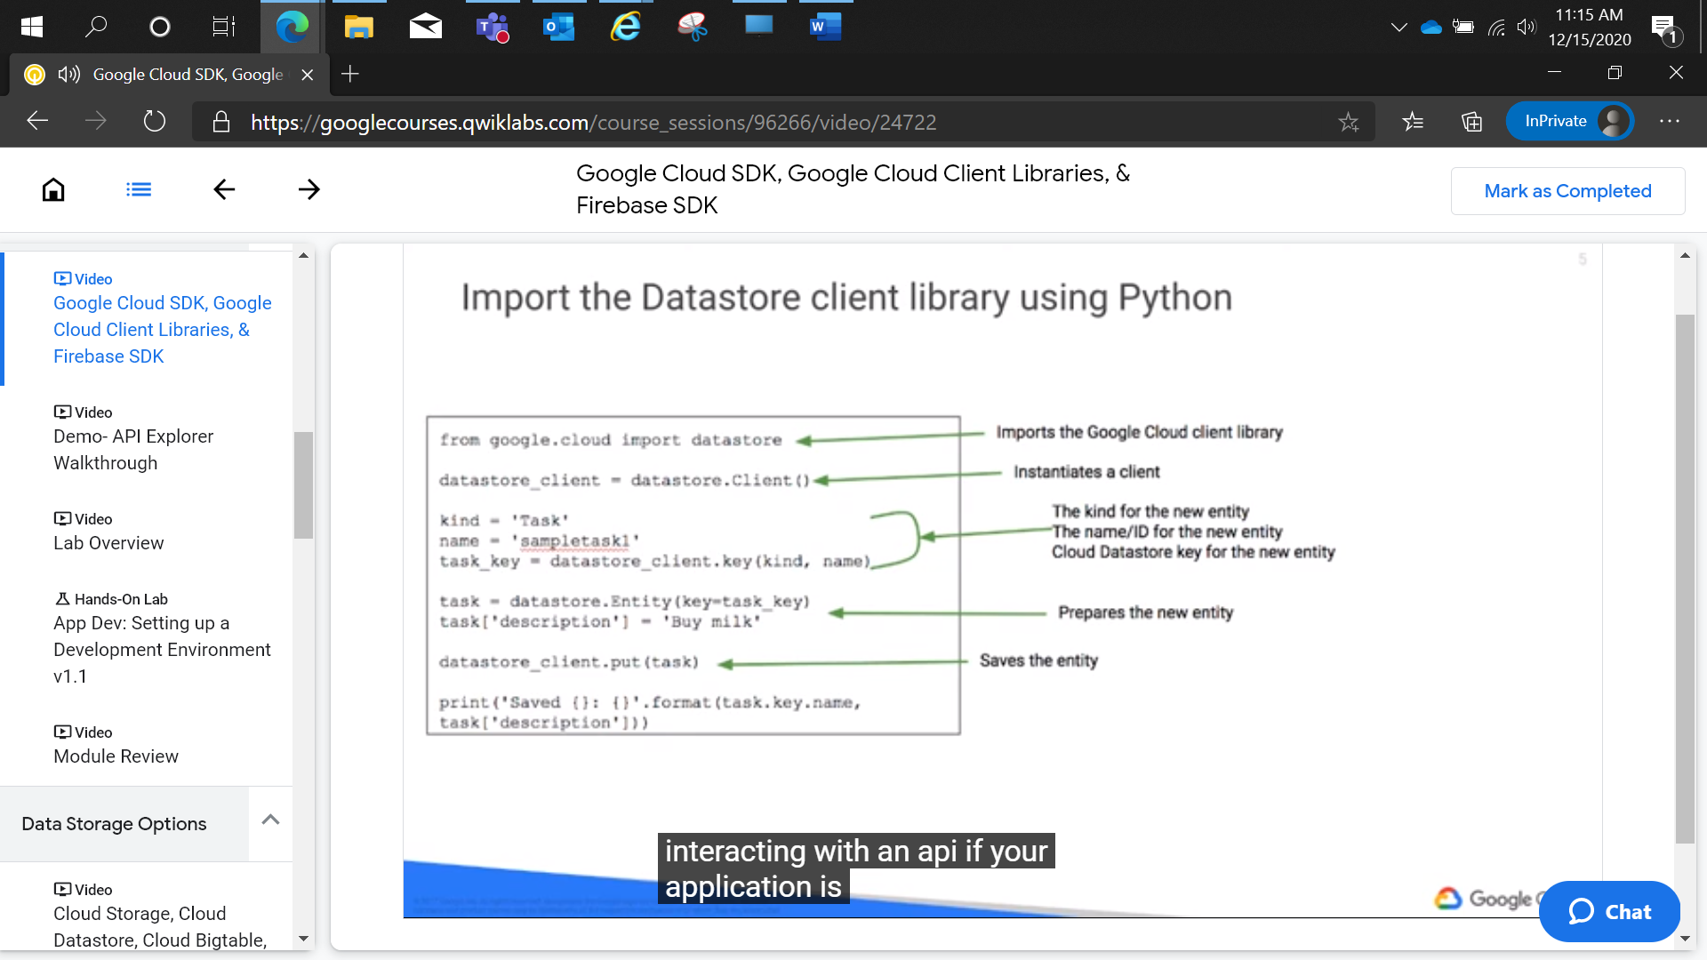

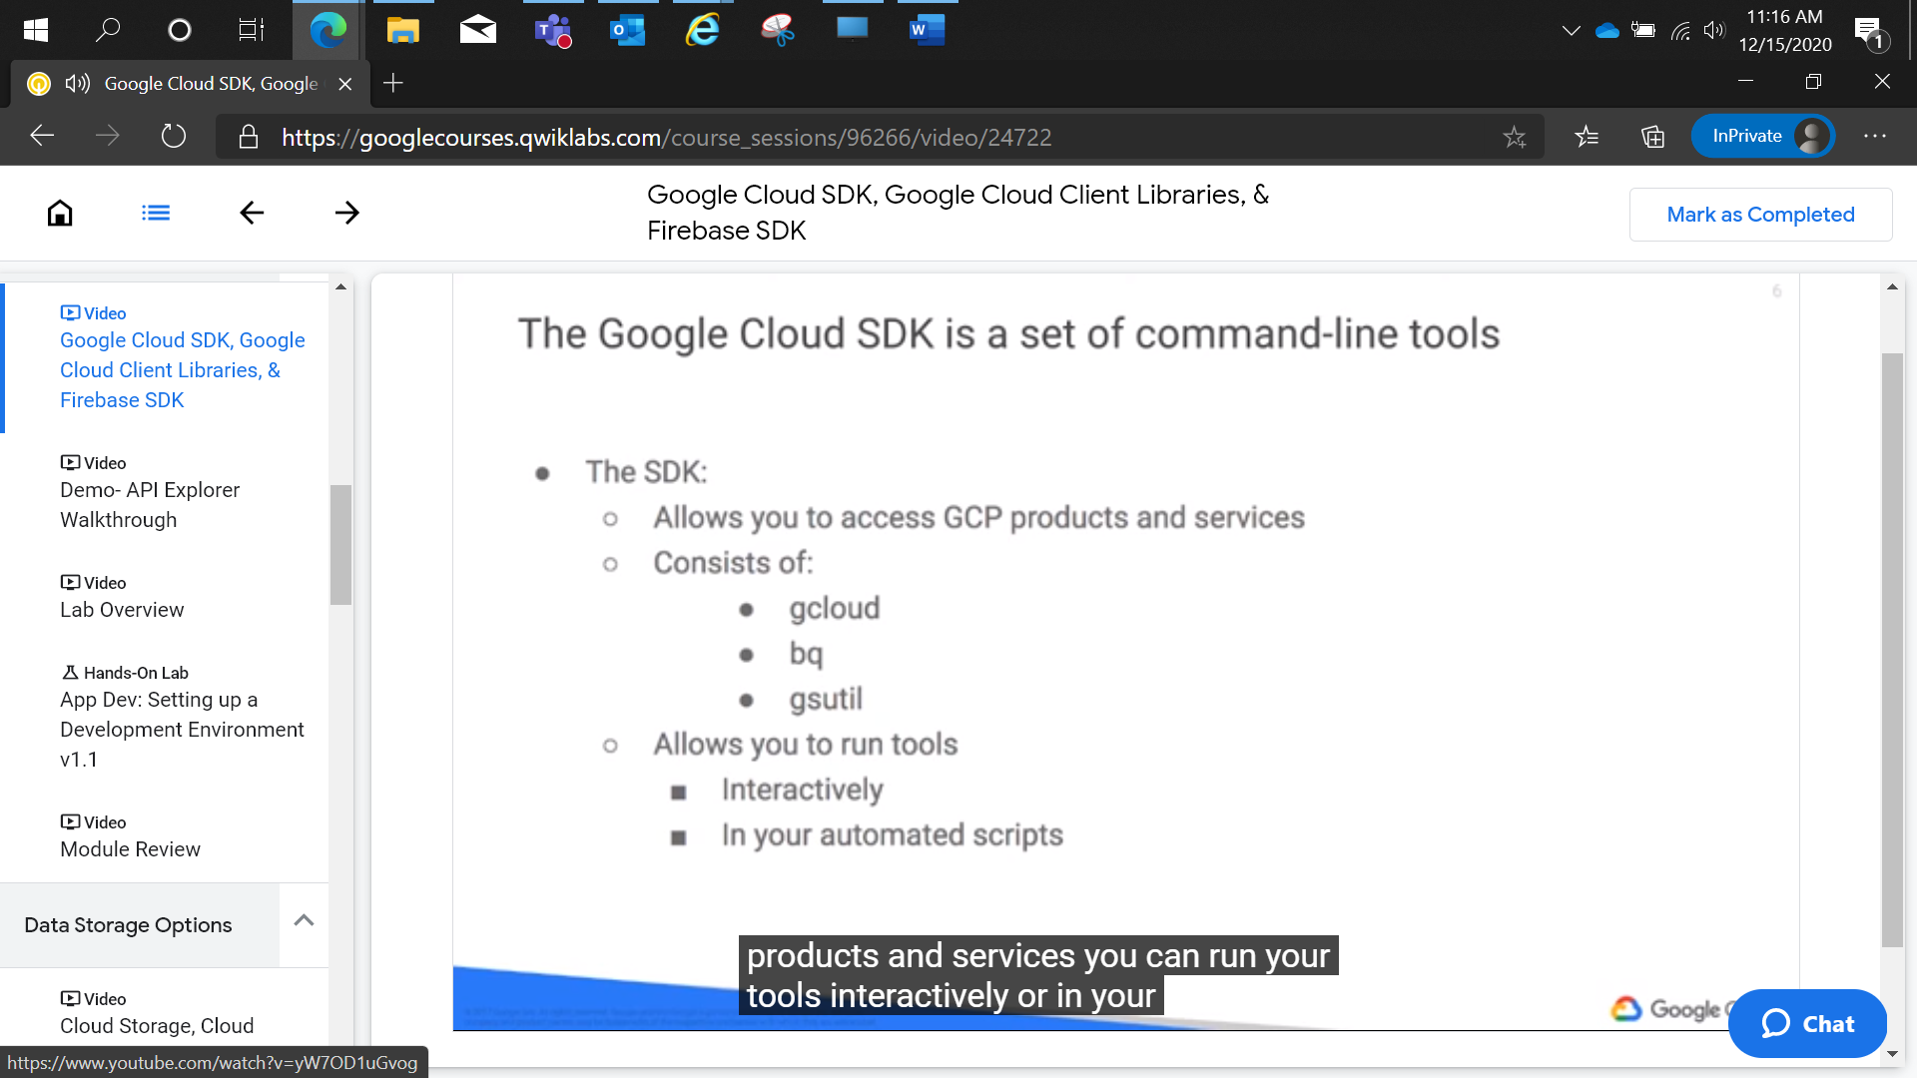

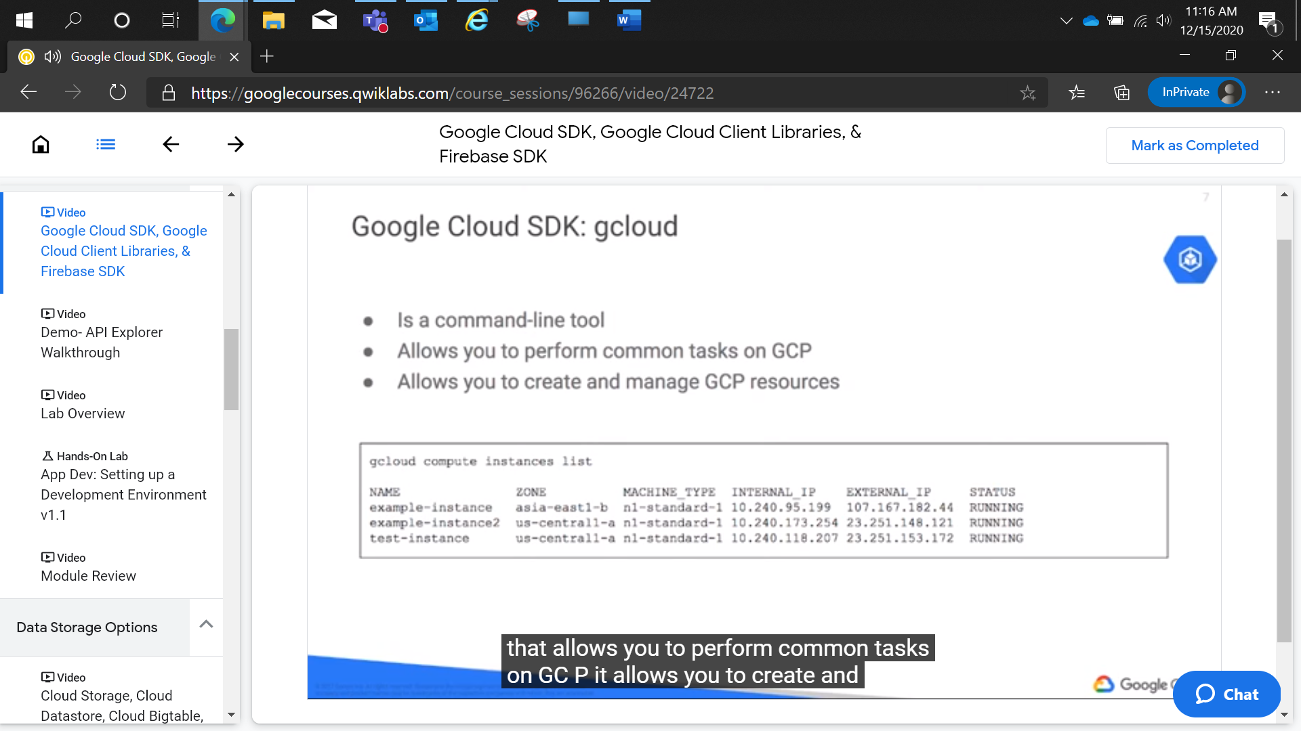

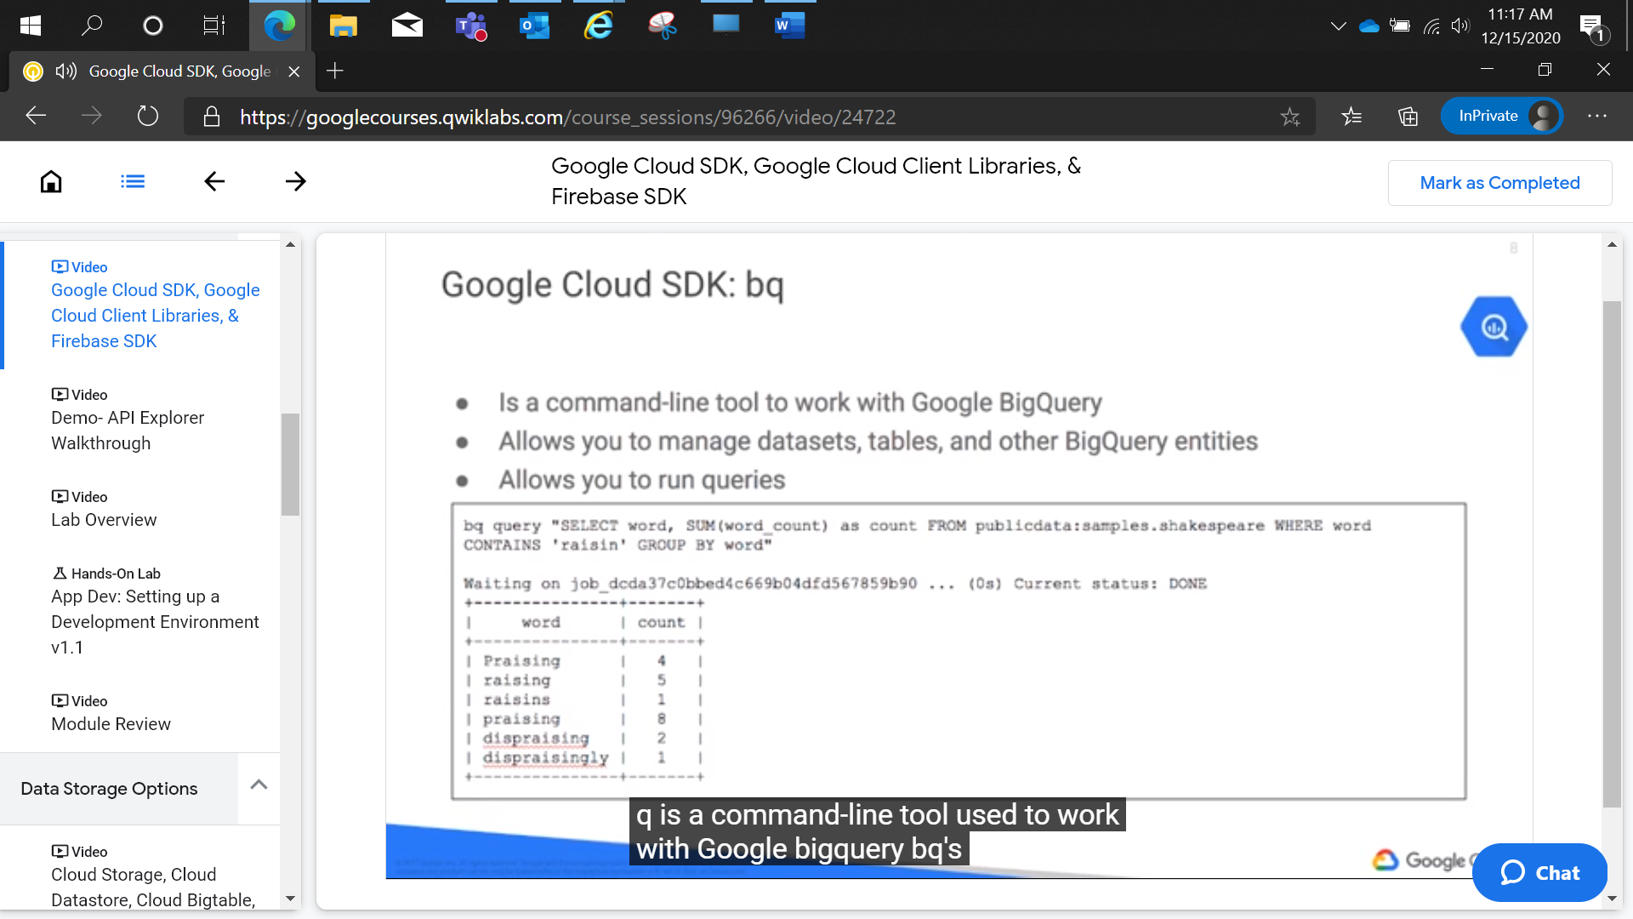

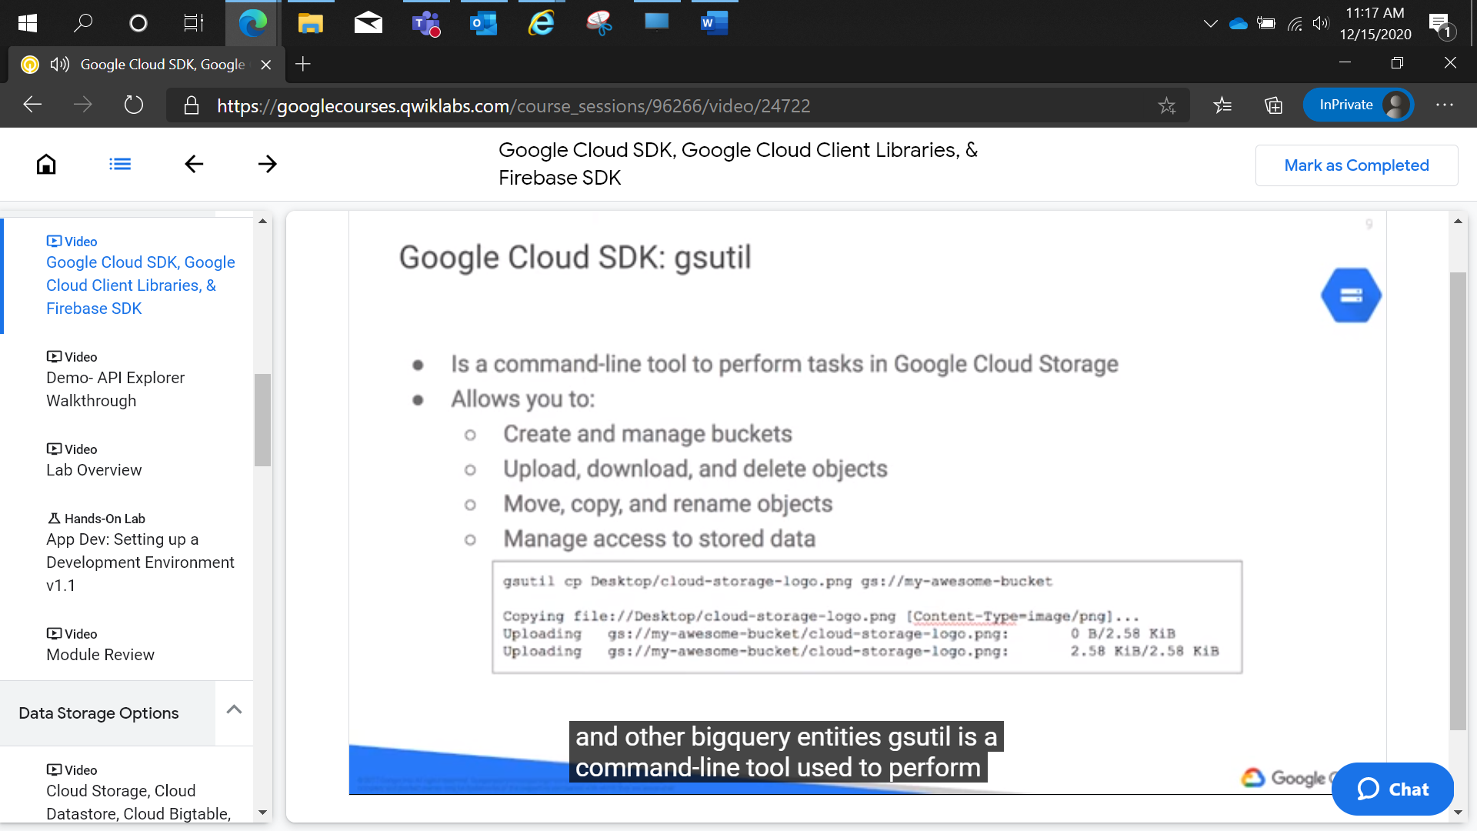

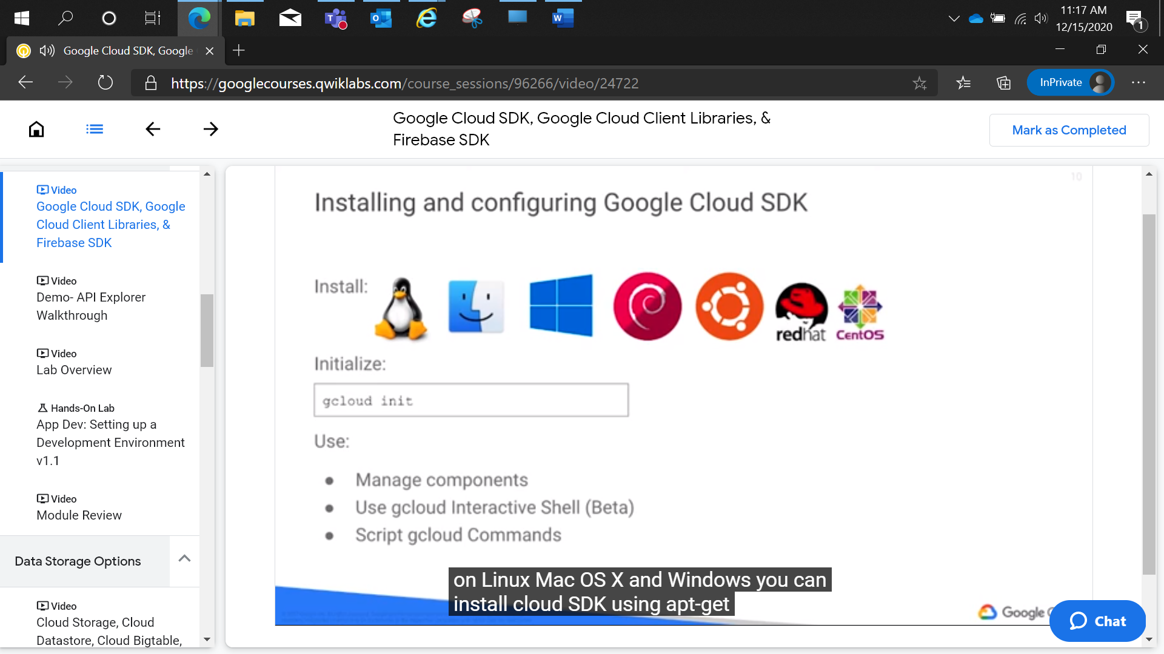

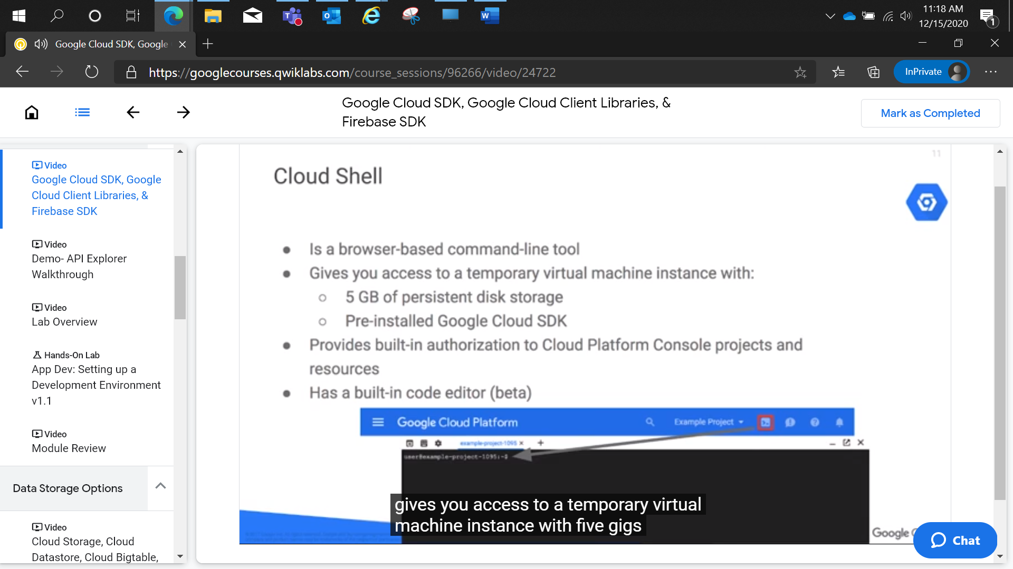

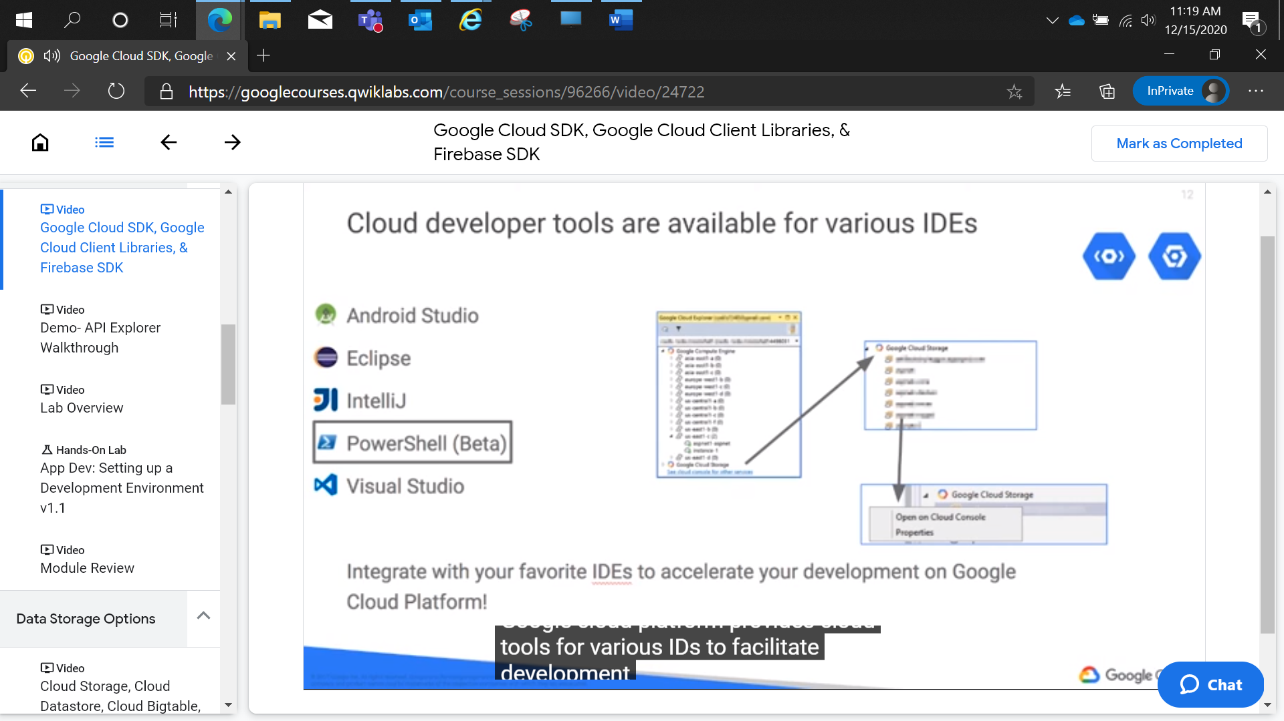

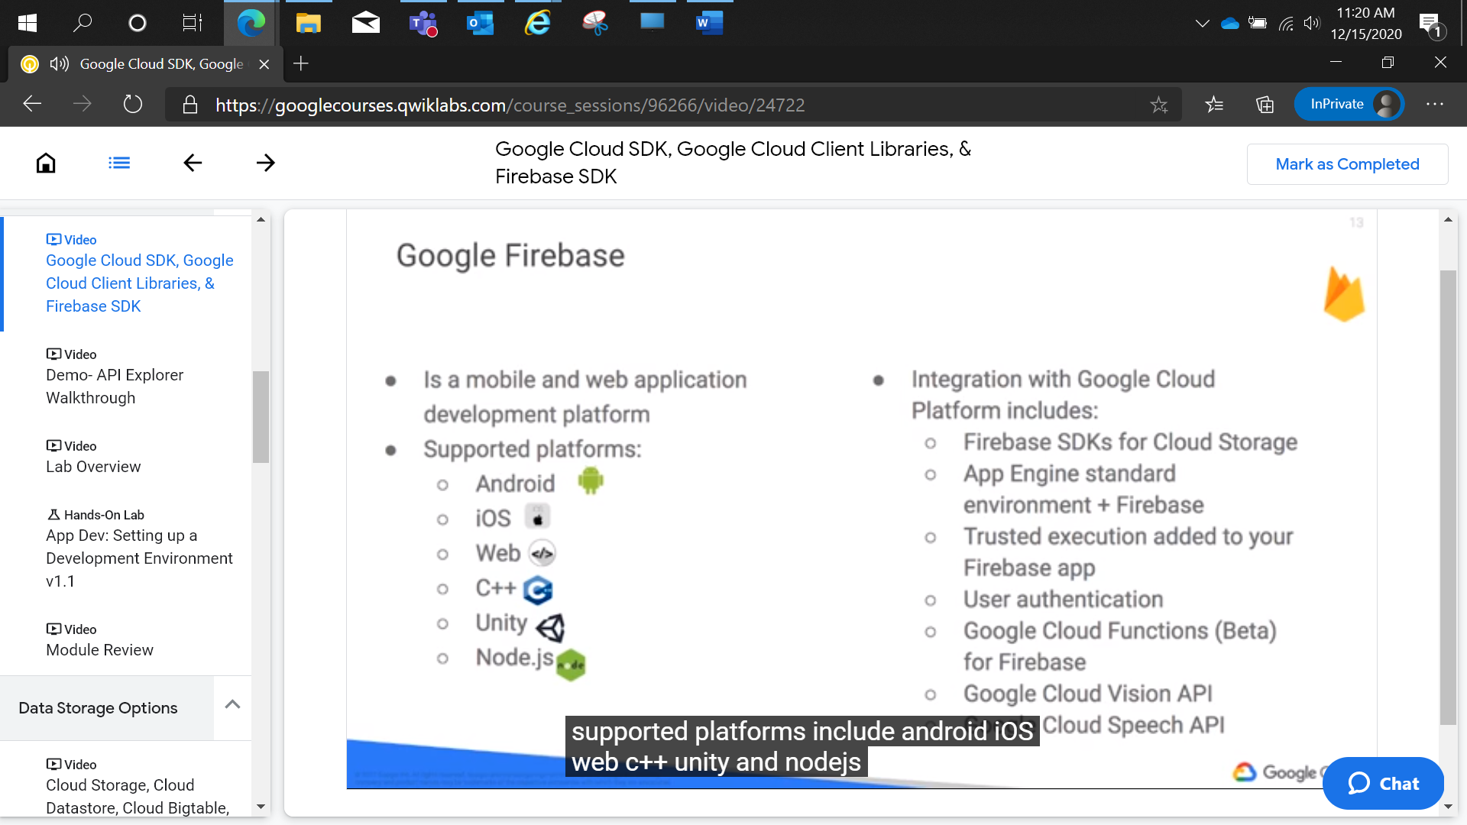

App Dev: Setting up a Development Environment v1.1

2 hoursFree

Rate Lab

**Overview**

In this lab, you will provision a Google Compute Engine virtual machine and install software libraries for Node.js software development on Google Cloud Platform.

**Objectives**

In this lab, you will learn how to perform the following tasks:

* Provision a Google Compute Engine instance.
* Connect to the instance using SSH.
* Install software on the instance.
* Verify the software installation.

**Setup**

For each lab, you get a new GCP project and set of resources for a fixed time at no cost.

1. Make sure you signed into Qwiklabs using an **incognito window**.
2. Note the lab's access time (for example,  and make sure you can finish in that time block.

There is no pause feature. You can restart if needed, but you have to start at the beginning.

1. When ready, click .
2. Note your lab credentials. You will use them to sign in to Cloud Platform Console. 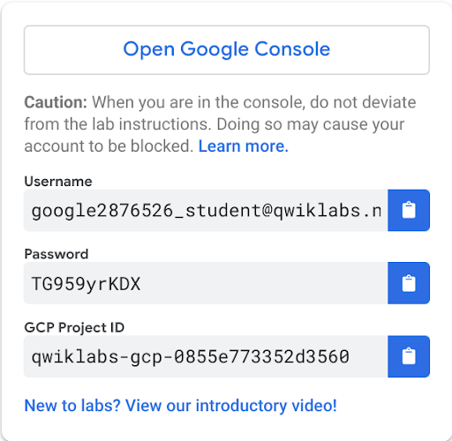
3. Click **Open Google Console**.
4. Click **Use another account** and copy/paste credentials for **this** lab into the prompts.

If you use other credentials, you'll get errors or **incur charges**.

1. Accept the terms and skip the recovery resource page.

Do not click **End Lab** unless you are finished with the lab or want to restart it. This clears your work and removes the project.

**Task 1: Creating a Compute Engine Virtual Machine Instance**

In this section, you will use the Google Cloud Platform Console to provision a new Google Compute Engine virtual machine instance.

1. In the **Cloud Platform Console**, on the **Navigation menu**, click **Compute Engine**.
2. On the **VM Instances** page, click **Create**.
3. On the **Create an instance** page, for **Name** type **dev-instance**, select **us-central1** for region and **us-central1-a** for the zone.

**GCP Regions and Zones**

Google Cloud Platform offers products and services in multiple distinct geographic locations, called regions.

Each region has multiple distinct zones. Each zone is isolated from other zones in terms of power and internet connectivity.

1. In the **Identity and API access > Access Scopes** section, select **Allow full access to all Cloud APIs**.
2. In the **Firewall** section, enable **Allow HTTP traffic**.
3. Leave the remaining settings as their defaults, and click **Create**.

It takes about 20 seconds for the virtual machine to be provisioned and started.

1. On the **VM instances** page, in the row for the **dev-instance**, click **SSH** (in the **Connect** column).

This launches a browser-hosted SSH session. If you have a popup blocker, you may need to click twice.

There's no need to configure or manage SSH keys.

Click *Check my progress* to verify the objective.

Create a Compute Engine Virtual Machine Instance

Check my progress

**Task 2: Install software on the VM instance**

1. In the SSH session, to update the Debian package list, execute the following command:
2. sudo apt-get update

content_copy

1. To install Git, execute the following command:
2. sudo apt-get install git

content_copy

If prompted, press Enter.

1. To download the Node.js setup script, execute the following command:
2. curl -sL https://deb.nodesource.com/setup_6.x | sudo -E bash -

content_copy

1. To install npm and Node.js, execute the following command:
2. sudo apt install nodejs

content_copy

Click *Check my progress* to verify the objective.

Install software on the VM instance

Check my progress

**Task 3: Configure the VM to Run Application Software**

In this section, you will verify the software installation and run some sample codes.

1. To check the version of Node.js, execute the following command:
2. node -v

content_copy

You should see the Node.js version number for version 6.

1. To clone the class repository, execute the following command:
2. git clone https://github.com/GoogleCloudPlatform/training-data-analyst

content_copy

Click *Check my progress* to verify the objective.

Clone the repository

Check my progress

1. To change the working directory, execute the following command:
2. cd ~/training-data-analyst/courses/developingapps/nodejs/devenv/

content_copy

1. To run a simple web server, execute the following command:
2. sudo node server/app.js

content_copy

1. Return to the Cloud Console VM instances list, and click on the External IP address for the dev-instance.

You should see a Hello GCP dev! message from Node.js.

1. Return to the SSH window, and stop the application by pressing **Ctrl+C**.
2. To install the Node.js library for Compute Engine, execute the following command:
3. npm install

content_copy

1. To run a simple Node.js application that lists Compute Engine instances, execute the following command:
2. node list-gce-instances.js

content_copy

Many details about your machine should appear in the terminal window.

Warning: If you try to do this on your own machine, it will not work if no credentials have been set up to access GCP on your machine.

**End your lab**